**Methods**

In order to check for selective reporting and make sure that what we are observing is not simply the result of publication bias and p-hacking, we carried out *p*-curve analyses based on Simonsohn, Nelso, and Simmons (2014). According to Simonsohn et al. (2014), a *p*-curve presents visually the distribution of the *p* values that are statistically significant for a set of studies (*p*s <. 05), and when the effect truly exists, for example, if we set the significance level to 0.05, then we should expect to see more low *p* values (0.1s) than *p* values that although are smaller than 0.05, but very close to it (0.04s).Therefore, we can conclude that there is no need to worry about publication bias only when the *p*-curve is right-skewed, indicating a majority of low *p*s in the set of studies that are included in our meta-analysis.

The *p*-curve analysis was conducted not only for effect sizes of all the studies that are in our meta-analysis, but was also carried out separately for the agentic and communal constructs. This is inspired by one of the reviewers, who has proposed that it is possible that publication bias may be observed for the agentic constructs, in that they are the focal constructs in most published studies on narcissistic self-enhancement.

The *p*-curve analyses were realized via the online APP 3.0 (<http://www.p-curve.com/app3/>) developed by Simonsohn, Nelson, and Simmons.

**Results:**

In order to meet the independence assumption of *p*-curve analysis, composite effect sizes instead of original effect sizes were used. A total of 37 composite effect sizes were entered to the online APP along with the sample size. For example, the first composite effect size comes from a sample of 145 participants, and the effect size, which is the correlation between narcissism and self-enhancement, equals -0.13. Therefore, we entered r (145) = -.13 in the box on the APP website along with all other 36 results in the same format.

Out of the 37 composite effect sizes, 13 of them were excluded from *p*-curve because they were not statistically significant at the significance level of 0.05. The remaining 24 significant results were included in the *p*-curve.

In Figure 1 the distribution of the *p* values of all significant results are demonstrated, presenting a curve of *p* values that is statistically significantly right-skewed. Therefore, we can conclude that there is indeed evidential value in the set of studies that are included in our meta-analysis, and the effect sizes we have are not the results of publication bias or selective reporting.

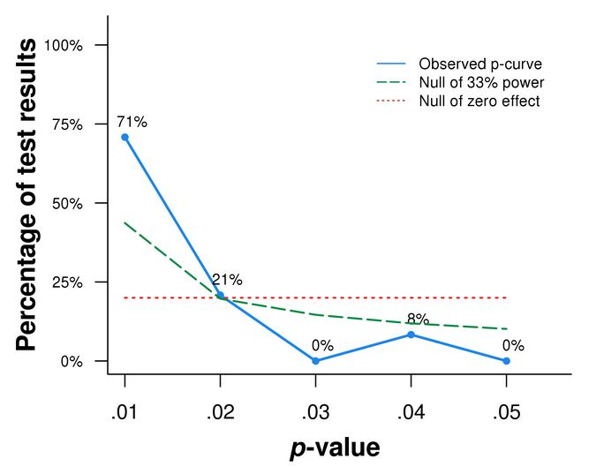

*Figure 1*. *P*-curve containing *p* values of all statistically significant effect sizes (α= 0.05). N= 24 *p* values. 71% of all the significant results have *p* values smaller or equal to 0.01, and 92% no larger than 0.02. The curve is significantly right-skewed based on both the binomial test (which tests the share of significant results *p* <.025; *p* < 0.0001) and the continuous test (Z = -12.61, *p* < .0001).

Then we conducted *p*-curve analyses for on both agentic constructs and communal constructs, respectively.

Out of the 29 statistically independent composite effect sizes for agentic constructs, 2 of them were excluded from *p*-curve because of insignificance. The remaining 27 significant results were included in the analysis.

Figure 2 displays the distribution of the *p* values of all significant results for agentic constructs, presenting a curve of *p* values that is statistically significantly right-skewed, indicating that studies on agentic constructs contain evidential value, and are not subject to publication bias or p-hacking.

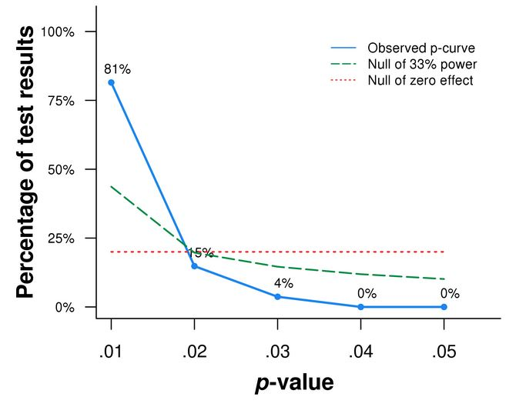

*Figure 2*. *P*-curve containing *p* values of all statistically significant effect sizes on agentic constructs (α= 0.05). N = 27 *p* values. 81% of all the significant results have *p* values smaller or equal to 0.01, and 96% no larger than 0.02. The curve is significantly right-skewed based on both the binomial test (p< 0.0001) and the continuous test (Z = -14.55, *p* < .0001).

We obtained 11 statistically independent effect sizes for communal constructs, and only 3 of them are statistically significant, and thus are included in the analysis.

Figure 3 demonstrated the distribution of the *p* values of all significant results for communal constructs. The *p*-curve is neither significantly right-skewed nor left-skewed, which should be the result of the extremely small sample size (N=3). However, out of the 3 significant effect sizes, two of them do have *p*-values that are smaller than 0.02. Also, considering the fact that most effect sizes (8 out of 11) we have for communal constructs are not even statistically significant to be included in the analysis, yet they were honestly reported by the authors, we believe that it is unnecessary to worry about *p*-hacking in studies looking at self-enhancement on communal constructs.

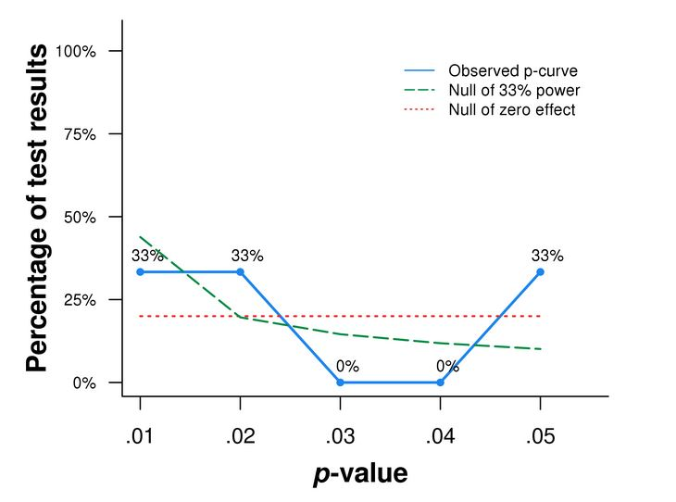

Figure 3. The *p*-curve of all significant composite effect sizes for communal constructs is neither right-skewed (binomial test: *p* = .5; continuous test: Z = 0.3, *p* = .619) nor left-skewed (binomial test: *p* = .875; continuous test: Z = -0.3, *p* = .381). N= 3 *p* values.

To conclude, via *p*-curve analyses for (1) all statistically independent composite effect sizes in our meta-analysis, (2) all independent composite effect sizes for agentic constructs, and (3) all independent composite effect sizes for communal constructs, we can say that there is no evidence of *p*-hacking among the studies that are included in our meta-analysis. When looking at all composite effect sizes and those for agentic constructs only, we obtained significantly right-skewed *p*-curve, indicating the existence of evidential values and absence of *p*-hacking or publication bias. When looking at effect sizes for communal constructs, even though the *p*-curve is neither right-skewed nor left-skewed, there doesn’t seem to be publication bias because of the fact that a lot more effect sizes reported are insignificant than significant.